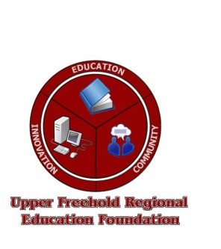
UFREF’s 5th Annual
Sno-Ball Softball Tournament
Sponsorship Opportunities

The Upper Freehold Regional Education Foundation (UFREF) is pleased to announce that the 5th Annual Sno-Ball Softball Tournament will be held on Saturday, February 11, 2012, and promises to be full of fun and excitement – and hopefully a lot of snow!

250+ people are expected to attend, consisting of players (16 teams), their friends and family, spectators and community leaders. Sponsorship is an ideal way for your company or business to receive exposure while at the same time support education in the Upper Freehold Regional School District.

Sponsorship Levels:

Grand Slam Sponsor - $1,000
- Tournament title sponsor (e.g. ABC Company Sno-Ball Softball Tournament to benefit UFREF)
- Your company name/logo featured in all print or promotional materials
- Your company logo on UFREF website
- Link to your company website
Sponsorships are secured only by cash or checks payable to:

UFREF
P.O. Box 109
Allentown, NJ 08501

- Your company logo on shirts
- Publicity in all news releases
Home Run Sponsor - $500
- Your company logo on UFREF website
- Link to your company website
- Your company logo on shirts
- Publicity in all news releases
Singles Sponsor - $250
- Your company logo on UFREF website
- Your company logo on shirts
- Publicity in all news releases
Base-On-Balls Sponsor - $100
- Your company logo on shirts
- Publicity in all news releases

UFREF must receive all signed sponsorship agreements, logos and payment by January 27, 2012 to make production deadlines.

For more information, please contact Jim Derasmo at either: (917) 842-6723 or derazz@optonline.net.

To learn more about the UFREF, please visit our website at: www.ufref.org

Upper Freehold Regional Education Foundation

P.O. Box 109 • Allentown, NJ 08501

